
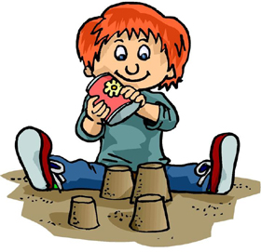
 |  | How many words can you make out of sand castle?
 |  | S A N D C A S T L E
 |  |  | ___________ |  |  | ___________
 |  |  | ___________ |  |  | ___________
 |  |  | ___________ |  |  | ___________
 |  |  | ___________ |  |  | ___________
 |  |  | ___________ |  |  | ___________
 |  |  | ___________ |  |  | ___________
 |  |  | ___________ |  |  | ___________
 |  |  | ___________ |  |  | ___________
 |  |  | ___________ |  |  | ___________
 |  |  | ___________ |  |  | ___________
 |  |  | ___________ |  |  | ___________
Did you find? |  |  |  |  |  |  | 
 | A bird’s bed.
 | An ocean animal.
 | Something to catch fish with.
 | The place where you catch fish.
 | The opposite of first.
 | A number.
 | An insect.
 | The opposite of more.
 | A time when things are cheap.
 | Something to drink.
 | A place to sit.
Difficult: | Information.
 | The month and the day.

www.bogglesworldesl.com

