MISSING HIKER
(see www.faughnan.com/brian.html for more information)

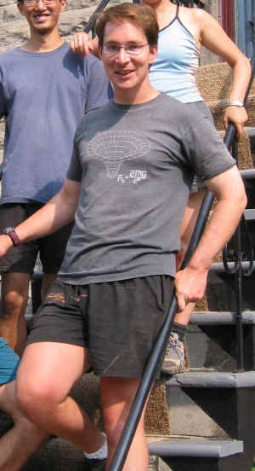Did you see Brian Faughnan on or after July 11th, 2002? Any information may guide a search for him.
Brian was last seen Friday July 12th at 10:30am leaving the Shoestring Lodge in Whistler, BC, Canada on a day hike. Perhaps you saw him walking by, or spoke with him. He is a fast hiker, and he might have passed you on a trail. He might have been coming up the mountain trail that you were going down, since he started later in the day. He probably had a yellow day pack with an ice-axe on the back and he was probably wearing shorts and a t-shirt when he left the Lodge. He might have had a denim baseball cap on. A red jacket might have been strapped to the outside of the pack. That Friday was a comfortable sunny day, as were the days before. Early Saturday morning the weather would turn rainy, cool, and foggy.
Brian would have struck you as a tall (6'0") pleasant faced tanned athletic man in his early thirties. If you spoke with him you might have noticed scarring of his left lower arm (old fracture). He was blind in the right eye, and if you spoke he might have turned slightly to see you with his left eye better. When he's hiking vigorously his face turns quite red, particularly on the right side.
Brian's passions have been mountains, the outdoors, and film. Prior to moving into film he worked as an aerospace engineer. He might have spoken of living in Montreal, and having recently traveled to Vancouver to go exploring with a friend. He was on the first day of a BigFoot Tours bus outing that was going on to Banff.

Contact: Corporal Sellers, RCMP Reference File 02-4306 voice: 604-932-3044, fax: 604-905-1961 OR John Faughnan jfaughnan@mindspring.com 651-699-0920

