TEMPORARY OCCUPANCY AGREEMENT

THIS TEMPORARY OCCUPANCY AGREEMENT (the “Agreement”) is made this ____ day of June, 2013, by and between 1910 Murphy, LLC, first party, (hereinafter called “Landlord”), having an address of 619 Edgewood Avenue, Atlanta, GA 30312, and Woodridge Production, Inc, second party, (hereinafter called “Tenant”), having an address of 10202 West Washington Blvd, Culver City, Ca 90232.

WITNESSETH:

1. LEASED PREMISES. The Landlord, for and in consideration of the rents, covenants, agreements and stipulations hereinafter mentioned, reserved and contained, to be paid, kept and performed by the Tenant, has leased and rented, and by these presents does lease and rent, unto the Tenant, and the Tenant hereby agrees to lease and take upon the terms and conditions which hereinafter appears, the following described property (exclusive of any easement for light or air), hereinafter called “Leased Premises”, to wit:

Approximately 42,000 square feet of previously occupied office and warehouse space known as 1910 Murphy Avenue, Atlanta, GA 30310 (the “Leased Premises”). located at , containing (the “Total Premises”), and a portion of the building commonly known as (the “Building”), containing square feet.

2. TERM AND PREPARATION/ACCEPTANCE OF LEASED PREMISES. The term of this Agreement shall commence on June 24, 2013 and shall expire on December 31, 2013. Thereafter this Agreement shall continue on a “month-to-month” basis unless cancelled with a thirty (30) day prior written notice from Landlord or Tenant.

a. Site Plan. One sheet dated 2013 as last revised through 2013, covering the Site Plan and Building containing 115,000 square feet, and showing the 42,000, square feet to be leased, as outlined in red, is attached hereto as Exhibit “A”, and by this reference made a part hereof. Notwithstanding any other provision of this Section 2.1. or any plan mentioned herein, in no event shall any plan incorporated herein be effective to lease and rent more property than is described as the “Total Premises in Section 1. of this Agreement.

b. Warehouse Plan. One sheet dated 1980, as last revised through 1980, covering the Warehouse Plan of the existing 115,000 square feet, and showing the 42,000 square feet to be leased, as outlined in red, is attached hereto as Exhibit “B”, and by this reference made a part hereof. Notwithstanding any other provision of this Section 2.b., or any plan mentioned herein, in no event shall any plan incorporated herein be effective to lease and rent more property than is described as the “Total Premises” in Section 1. of this Agreement.

Landlord has performed the following work prior to Tenant’s occupancy:

- Unless otherwise specified therein, the Leased Premises shall be delivered to Tenant on an “as is”, “where is” basis.
- Install lighting and electrical outlets within 14 days of occupancy.

3. BASE RENT RATE. The rental rate for this Agreement shall be $2.38 per square foot per year payable as eight thousand three hundred thirty-three dollars and 33/100 ($8,333.33) monthly in advance on the first day of each month. Rental for any partial month shall be $277.78 per day.

4. REAL ESTATE TAXES. Tenant agrees to pay Landlord promptly on the first day of each month in advance during the term of this Agreement a monthly tax escrow amount of $ per square foot per year payable as ($ ) per month toward payment of Tenant’s share of taxes for that year. Taxes for any partial month shall be $ per day. Landlord is responsible for real estate taxes.

5. COMMON AREA EXPENSES. The cost to Tenant for the grounds maintenance, expense for insurance carried by landlord as required in this Agreement, other miscellaneous common area charges and administrative fees shall be $ per square foot payable as ($ ) per month, payable monthly in advance as Additional Rent. Common Area Expense charges for any partial month shall be $ per day. Landlord is responsible for common area expenses.

- ADDRESS FOR PAYMENTS. Please remit payments to the following address:

1910 Murphy, LLC
619 Edgewood Avenue, Suite T-101
Atlanta, GA 30312

7. ADDITIONAL RENT. Any amounts that Tenant assumes or agrees to pay to Landlord under the provisions of this Agreement, including, without limitation, any sums that may become due by reason of any default of Tenant or failure on Tenant’s part to comply with the agreements, terms, covenants and conditions of this Agreement to be performed by Tenant, and any charges or expenses incurred by Landlord on behalf of Tenant under the terms of this Agreement shall be considered “Additional Rent” payable in the same manner and upon the same terms and conditions as the Gross Rent (Section 3.) reserved hereunder except as set forth herein to the contrary. Any failure on the part of Tenant to pay such Additional Rent when and, as the same shall become due shall entitle Landlord to the remedies available to it for non-payment of Gross Rent. Tenant’s obligations for payment of Additional Rent shall begin to accrue on the Agreement Commencement Date regardless of the Gross Rent Commencement Date.

8. LATE PAYMENT. If monthly rental or any other amount payable by Tenant under this Agreement is not paid within ten (10) days after the date such payment is due, Tenant shall pay to Landlord a late charge equal to five percent (5%) of the delinquent amount, and interest on the delinquent amount at the rate of fourteen percent (14%) per annum until paid.

9. SECURITY DEPOSIT. Tenant has deposited with landlord the sum of eight thousand three hundred thirty-three dollars and 33/100 ($8,333.33), receipt of which is hereby acknowledged. Said deposit shall be held by Landlord without interest as security for the faithful performance by Tenant of all the terms and covenants of this Agreement by Tenant to be observed and performed. In the event Tenant fails to perform or observe any of the agreements, covenants, conditions and provisions of this Agreement to be performed or observed by it, then at Landlord’s option, Landlord may, but shall not be obligated to, apply the security deposit, or so much thereof as may be necessary, to remedy any such failure by Tenant. Tenant shall immediately upon request to pay Landlord any such necessary to restore the security deposit to the full amount specified above. In the event of a sale, assignment, or other transfer of Landlord’s interest in the Total Premises, or a lease by Landlord of its interest in the Building, Landlord shall have the right to transfer the security deposit to the transferee, and Landlord shall be relieved of all liability Tenant for the return of such security deposit. Tenant shall look solely to the transferee for the return of such security deposit. In the event of a permitted assignment under this Agreement by Tenant, the security deposit shall be held by landlord as a deposit made by the permitted assignee and landlord shall have no further liability with respect to the return of said security deposit to the original Tenant.

10. UTILITIES. During Tenant’s occupancy of the space, utilities for the Leased Premises shall be accounted for as follows:

a. Water. The water and sprinkler services for the building covered by this Agreement are in the name of the Landlord. Landlord shall promptly pay said bill and invoice Tenant in accordance with this provision. If Tenant is the only occupant within Total Premises, Tenant’s pro rata share shall be deemed to be 100%. However, if there are other tenants in the Total Premises, Landlord shall invoice each tenant for its pro rata share with the numerator being the square feet occupied by Tenant and the denominator being the total occupied square footage in the building.

b. Gas. The gas service for the Total Premises covered by this Agreement is in the name of the Landlord. Landlord shall promptly pay the gas bill and invoice Tenant in accordance with this provision. If Tenant is the only occupant within the Total Premises, Tenant’s pro rata share shall be deemed to be 100%. However, if there are other tenants in the Total Premises, Landlord shall invoice each tenant for its pro rata share with the numerator being the square feet occupied by Tenant and the denominator being the total occupied square footage in the building.

c. Electricity. The electric service for the Total Premises covered by this Agreement is in the name of the Landlord. Landlord shall promptly pay the electric bill and invoice Tenant in accordance with this provision. If Tenant is the only occupant within the Total Premises, Tenant’s pro rata share shall be deemed to be 100%. However, if there are other tenants in the Total Premises, Landlord shall invoice each tenant for its pro rata share with the numerator being the square feet occupied by Tenant and the denominator being the total occupied square footage in the building.

11. REPAIRS BY LANDLORD. The Landlord agrees to keep in good repair the roof, foundations, exterior walls of the building and exterior paving containing or constituting a part of the Leases Premises; provided however, the Landlord shall not be responsible for the repair of glass and exterior doors and any and all repairs rendered necessary by the negligence of Tenant, its agents, employees or invitees. Landlord gives to Tenant exclusive control of the Leased Premises and shall be under no obligation to inspect said Leased Premises. Tenant shall promptly report in writing to Landlord any defective condition known to it, which landlord is required to repair, and failure to so report such defects shall make Tenant responsible to Landlord for any liability incurred by Landlord by reason of such defects.

12. USE. The Leased Premises shall not be used for illegal purposes, nor in any manner to vitiate the insurance or increase the rate of insurance on the Leased Premises.

13. CODES AND LICENSES. Tenant shall be responsible for compliance with all codes and government licenses related to its use of the Leased Premises.

14. EXTERIOR SIGNS. Tenant shall place no signs upon the outside walls or roof of the Leased Premises except with the written consent of the Landlord. Any and all signs placed on the Leased Premises by Tenant shall be maintained in compliance with rules and regulations governing such signs and the Tenant shall be responsible to Landlord for any damage caused by installation, use, or maintenance of said signs, and Tenant agrees upon removal of said signs to repair all damage incident to such removal.

15. TENANT FUNDED IMPROVEMENTS. Tenant shall not construct any build-out improvements to the Premises without prior written consent of Landlord.

16. MAINTENANCE OF LEASED PREMISES. Tenant shall keep the Leased Premises in as clean and orderly a manner as when received, and Tenant agrees that, upon termination of this Occupancy Agreement, the Leased Premises will be returned to Landlord cleaned and with all systems in the same condition as when first received, ordinary wear and tear excepted. Tenants shall be responsible for normal maintenance and/or repair of all systems pertinent to its occupancy and/or use during its occupancy. Tenant shall also maintain sufficient heat in the Leased Premises to protect any water pipes and/or sprinkler system therein from freezing.

17. LANDLORD ACCESS. As Landlord, we shall retain the right of access to the Leased Premises in order that we may show the Leased Premises to prospective tenants, make office modifications for a future long-term tenant, and determine the amount of space being occupied by Tenant. Tenant and Landlord shall retain the keys to the Leased Premises. Tenant grants than Landlord shall have access to the Leased Premises on each and every business day during normal business hours. Landlord reserves the right to lease other parts of the building so long as Tenant has secured access to their space and belongings.

18. INDEMNITY. Tenant agrees to indemnify and save harmless the Landlord against all claims for damages to persons or property by reason of the use or occupancy of the herein Leased Premises, and all expenses incurred by Landlord because thereof, including reasonable attorney fees and court costs.

19. INSURANCE AND WAIVER OF SUBROGATION. Tenant shall provide and keep in force the following insurance:

a. Commercial general liability and excess / umbrella insurance relating to Tenant’s business carried on, in or from the Leased Premises, for personal and bodily injury and death, and damage to others’ property, with combined limits of not less than $2,000,000.00 for any one accident or occurrence; and

b. All risk or fire insurance(including standard extended coverage and coverage for leakage from fire protective devices and other water damage) relating to Tenant’s fixtures, furnishings and all personal property of Tenant in the Leased Premises on a full replacement cost basis; and

c. Worker’s Compensation Insurance as required by applicable law, to be provided by Tenant’s payroll services company. Prior to the commencement of the Agreement term and thereafter, at least fifteen (15) days prior to the expiration date of any policy required of Tenant, or as soon as practicable thereafter, Tenant agrees to deliver to Landlord certificates evidencing the insurance coverage required of Tenant under this Agreement.

Said certificate confirm that landlord, its managing agent, and the holders of any Security Deeds are named as additional insureds as respects liability insurance only. Notice of cancellation will be in accordance with the policy provisions. The policies required to be carried by Tenant pursuant to the terms of this Agreement shall be issued by a company, licensed to do business in the State of Georgia.

Landlord shall waive all rights of recovery and all causes of action against Tenant for any loss occurring to the Leased Premises resulting form any of the perils insured against under such policy or policies of insurance carried by landlord regardless of cause, including the negligence of Tenant, but only to the extend of any recovery received by Landlord under such policy or policies of insurance. Landlord will cause these policies of insurance to include an endorsement to that effect. Conversely, Tenant shall waive all rights of recovery received under such policy or policies of insurance carried by Tenant, and Tenant will cause these policies of insurance to include an endorsement to that effect.

20. QUIET ENJOYMENT. Landlord represents and warrants that it has full right and authority to enter into this Agreement and agrees, for so long as Tenant pays the rental and performs the other covenants and agreements required of Tenant hereunder, to take all necessary steps to secure and to maintain for the benefit of Tenant, and that Tenant shall have and enjoy the peaceable and quiet possession of the Leased Premises for the Term, without hindrance, claim or molestation from Landlord or any person claiming by, through or under landlord.

21. AGENT. Pursuant to a separate agreement between Landlord and Raulet Property Advisors, LLC, Landlord shall be responsible for payment of the agent’s fees.

22. EXPANSION. Tenant shall have the ability to expand into any of the areas outlined in greed (Expansion Space) on Exhibit “B” (Warehouse Plan) hereof. Tenant shall notify Landlord, via facsimile, if Expansion Space is needed and will be billed for the additional space at the same rental rate per square foot as charged on the original space. Upon inspection, if Landlord discovered that Tenant is occupying Expansion Space without notifying Landlord, Tenant shall be obligated to pay rent on the entire bay occupied for the entire month expansion is discovered.

23. PARKING. The parking areas identified in yellow on Exhibit “A” (Site Plan) hereof are for the common use of all tenants of .

IN WITNESS WHEREOF, the parties herein have hereunto set their hands and seals the day and year first above written.

LANDLORD: 1910 Murphy, LLC

Name: Eugene Rice
Title:

TENANT: Woodridge Production, Inc.
A California Corporation

Name:
Title:

Exhibit A

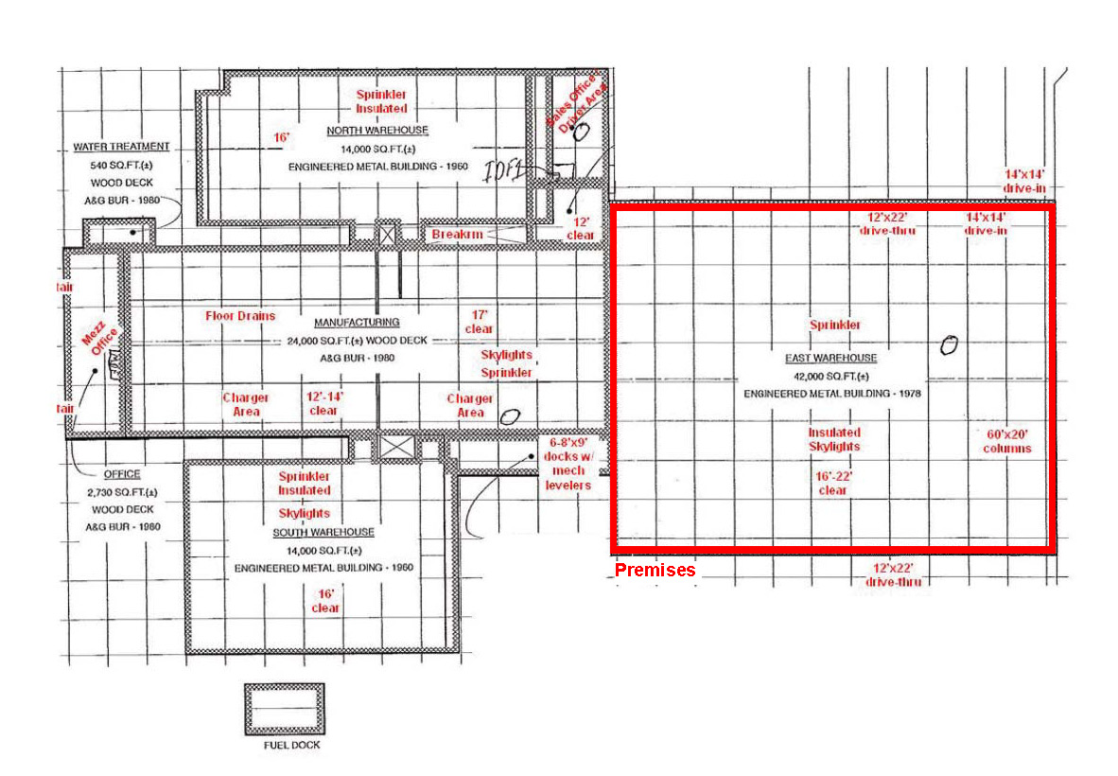
Exhibit B

