for-word.jpgfor-word.jpgfor-word.jpg­

SALARY CERTIFICATE

This is to certify that Mr. /Miss/Ms. (name) employee ID (number) is working with our reputed company as an (designation). He/she has been working with us since (date) and proved to be a very dedicated resource who has been very loyal to the company.

We are issuing this letter on the request of our employee and do not hold any liability on behalf of this letter or part of this letter on our company.

|  |  |  |
| --- | --- | --- |
| Employee State Insurance | | $560.00 |
| Provident Fund |  | $350.00 |
| Professional Tax |  | 4% |
|  |  |  |
|  | **Net Salary** | **$23,230.34** |

Manager

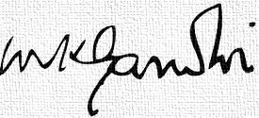

Location, City, State, Zip code

00 321-654-7890

info@company.com

DIRECTOR OF FINANCE

www.websitename.com

Proin venenatis tincidunt est sed nec nunc

PLACE YOUR TEXT HERE

COMPANY NAME